**Experiment no 1:** Ramesh’s basic salary is input through the keyboard. His dearness allowance is 40% of basic salary and house rent allowance is 20% of basic salary .Write a program to calculate his gross salary.

**Solution:-**

**Code:-**

/* find the gross salary*/

#include<stdio.h>

int main()

{

float gs,da,hra,bs;

printf("enter the basic salary of the employee\n");

scanf("%f",&bs);

/*calculate da and hra*/

da=.4*bs;

hra=.2/100*bs;

/*calculate gross salary*/

gs=bs+da+hra;

printf("the gross salary is =%f\n",gs);

printf("the HRA of employee id =%f\n",hra);

printf("the DA of employee is=%f\n",da);

return 0;

}

**Output:-**

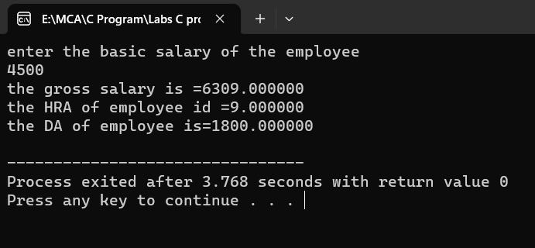

**Experiment no 2:** The distance between two cities (in km.) is input through the keyboard. Write a program to convert and print this distance in meters, feet, inches and centimeters

**Solution:-**

**Code:-**

**#include<stdio.h>**

**int main()**

**{**

**/*convert and print this distance*/**

**float dis,m,cm,miles,inc;**

**printf("enter hometown distance in km");**

**scanf("%f",&dis);**

**m+dis*1000;**

**cm=dis*10000;**

**inc=dis*39370;**

**miles=dis*0.6;**

**printf("\n %f distance in metres", m);**

**printf("\n %f distance in centimetres", cm);**

**printf("\n %f disttance in inches", inc);**

**printf("\n %f distance in miles", miles);**

**return 0;**

**}**

**Output:-**

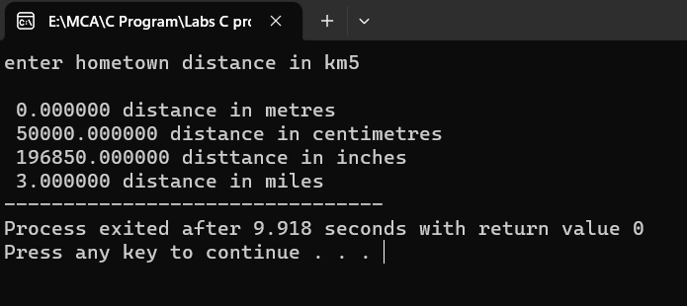

**Experiment no 3:** If the marks obtained by a student in five different subjects are input through the keyboard, write a program to find out the aggregate marks and percentage marks obtained by the student. Assume that the maximum marks that can be obtained by a student in each subject is 100.

**Solution:**-

**Code:-**

**#include<stdio.h>**

**int main()**

**{**

**/*find out the marks and presntage/\***

**float math,english,hindi,drawing,chemistry,physics,pers,total;**

**printf("enter the marks of math");**

**scanf("%f",&math);**

**printf("enter the marks of english");**

**scanf("%f",&english);**

**printf("enter the marks of hindi");**

**scanf("%f",&hindi);**

**printf("enter the marks of drawing");**

**scanf("%f",&drawing);**

**printf("enter the marks of chemistry");**

**scanf("%f",&chemistry);**

**printf("enter the marks of physics");**

**scanf("%f",&physics);**

**total=math+english+hindi+drawing+chemistry+physics;**

**printf("\n the total of numbers=%f",total);**

**pers=total/6;**

**printf("\n presentage=%f",pers);**

**scanf("%f",&physics);**

**return 0;**

}

**Output:-**

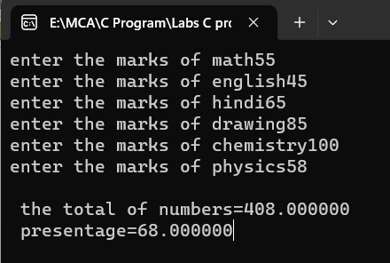

**Experiment no 4:** Temperature of a city in Fahrenheit degrees is input through the keyboard. Write a program to convert this temperature into Centigrade degrees.

**Solution:**-

**Code:-**

**#include<stdio.h>**

**int main()**

**{**

**/*fahrenheit convert to centigrade degree.*/**

**float cal,f;**

**printf("enter the temprature in fahrenheit:\n");**

**scanf("%f",&f);**

**cal=(f-32)*5/9;**

**printf("the temprature in calcious=%f",cal);**

**return 0;**

**}**

**Output:-**

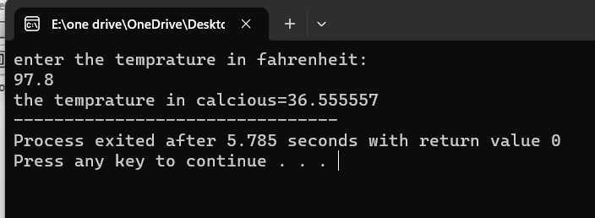

**Experiment no 5:** The length and breadth of a rectangle and radius of a circle are input through the keyboard. Write a program to calculate the area and perimeter of the rectangle, and the area and circumference of the circle.

**Solution:**-

**Code:-** #include<stdio.h>

int main()

{

//area of rectangle and circle

float length,breadth,rad,rectarea,cirarea,peri,circum;

printf("enter the length and breadth of the reactangle\n");

scanf("%f%f",&length,&breadth);

rectarea=length*breadth;

peri=2+(length+breadth);

printf("\nthe area of the reactangle is= %f\n ",rectarea);

printf("\nthe perimeter of the rectangle is =%f\n",peri);

//calcualting the area of the circle

printf("enter the radius of the circle\n");

scanf("%f",&rad);

cirarea=2*4.13*rad*rad;

circum=2*4.13*rad;

printf("\n the circumfarence of the circle is %f\n",circum);

printf("the area of the circle is=%f\n",cirarea);

return 0;

}

**Output:-**

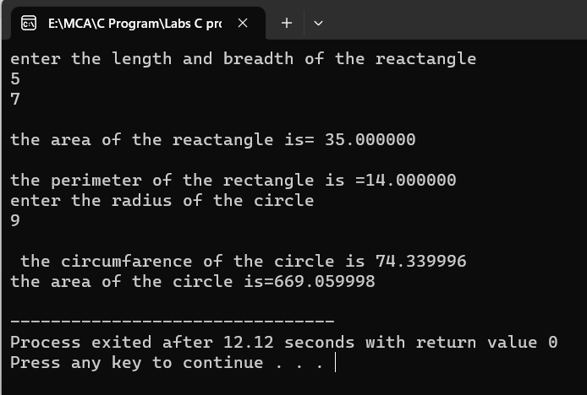

**Experiment no 6:** Paper of size AO has dimensions 1189 mm x 841 mm. Each subsequent size A(n) is defined as A(n-1) cut in half parallel to its shorter sides. Thus paper of size A1 would have dimensions 841 mm x 594 mm. Write a program to calculate and print paper sizes A0, A1, A2, AB.

**Solution:-**

**Code:-**

**#include<stdio.h>**

**int main()**

**{**

**Float a0_a,a0_b,a1_a,a1_b,a2_a,a2_b,a3_a,a3_b,a4_a,a4_b,a5_a,a5_b,a6_a,a6_b,a7_a,a7_b,a8_a,a8_b;**

**a0_a=1189;**

**a0_b=841;**

**a1_a=a0_a/2;**

**a1_b=a0_b/2;**

**printf("\n a1:%f*%f",a1_a,a1_b);**

**a2_a=a1_a/2;**

**a2_b=a1_b/2;**

**printf("\n a2:%f*%f",a2_a,a2_b);**

**a3_a=a2_a/2;**

**a3_b=a2_b/2;**

**printf("\n a3:%f*%f",a3_a,a3_b);**

**a4_a=a3_a/2;**

**a4_b=a3_b/2;**

**printf("\n a4:%f*%f",a4_a,a4_b);**

**a5_a=a4_a/2;**

**a5_b=a4_b/2;**

**printf("\n a5:%f*%f",a5_a,a5_b);**

**a6_a=a5_a/2;**

**a6_b=a5_b/2;**

**printf("\n a6:%f*%f",a6_a,a6_b);**

**a7_a=a6_a/2;**

**a7_b=a6_b/2;**

**printf("\n a7:%f*%f",a7_a,a7_b);**

**a8_a=a7_a/2;**

**a8_b=a7_b/2;**

**printf("\n a8:%f*%f",a8_a,a8_b);**

**return 0;**

**}**

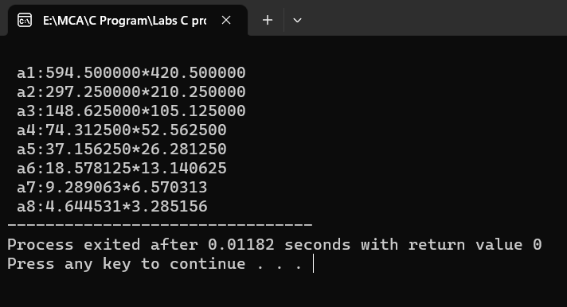

**Output:-**

**Lab Activity #2**

**Experiment no 1:** WAP to take check if the triangle is valid or not. If the validity is established, do check if the triangle is isosceles, equilateral, right angle, or scalene. Take sides of the triangle as input from a user.

**Soultion:-**

**Code:-**

#include<stdio.h>

int main()

{

int x,y,z;

printf("enter the sides of triangles\n");

scanf("%d%d%d",&x,&y,&z);

if((x==y)&&(y==z))

{

printf("equilateral");

}

else if((x==y)||(y==z)||(z==x))

{

printf("isosceles");

}

else

{

printf("scalen");

}

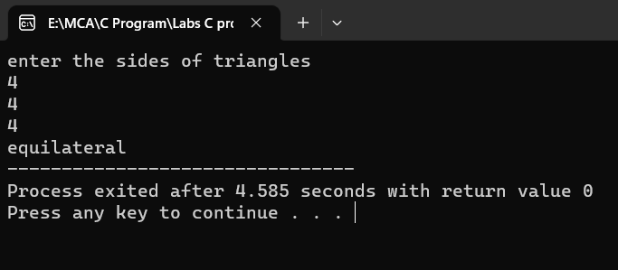 return 0;

}

**Output:-**

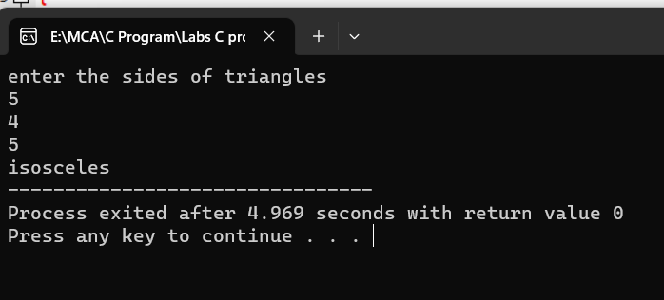

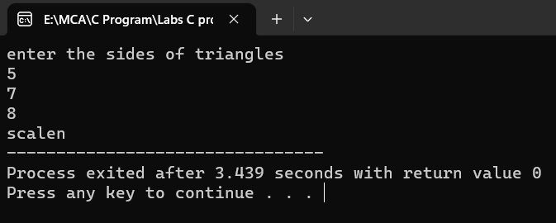

**Experiment no 2:** WAP to compute the BMI Index of the person and print the BMI values as per the following ranges. You can use the following formula to compute BMI= weight(kgs)/Height(Mts)*Height(Mts).

|  |  |
| --- | --- |
|  | **BMI** |
| **Starvation** | **<15** |
| **Anorexic** | **15.1 to 17.5** |
| **Underweight** | **17.6 to 18.5** |
| **Ideal** | **18.6 to 24.9** |
| **Overweight** | **25 to 25.9** |
| **Obese** | **30 to 39.9** |
| **Morbidity Obese** | **40.0 above** |

**Solution:-**

**Code:-**

#include <stdio.h>

int main()

{

float weight, height, bmi;

// Input weight in kilograms

printf("Enter your weight in kilograms: ");

scanf("%f", &weight);

// Input height in meters

printf("Enter your height in meters: ");

scanf("%f", &height);

// Calculate BMI

bmi = weight / (height * height);

// Print the BMI value

printf("Your BMI is: %.1f\n", bmi);

// Determine the BMI category and print it

if (bmi < 15.0)

{

printf("BMI Category: Starvation\n");

}

else if (bmi >= 15.1 || bmi <= 17.5)

{

printf("BMI Category: Anorexic\n");

}

else if (bmi >= 17.6 || bmi <= 18.5)

{

printf("BMI Category: Underweight\n");

}

else if (bmi >= 18.6 || bmi <= 24.9)

{

printf("BMI Category: Ideal\n");

}

else if (bmi >= 25.0 || bmi <= 25.9)

{

printf("BMI Category: Overweight\n");

}

else if (bmi >= 30.0 || bmi <= 39.9)

{

printf("BMI Category: Obese\n");

}

else

{

printf("BMI Category: Morbidity Obese\n");

}

return 0;

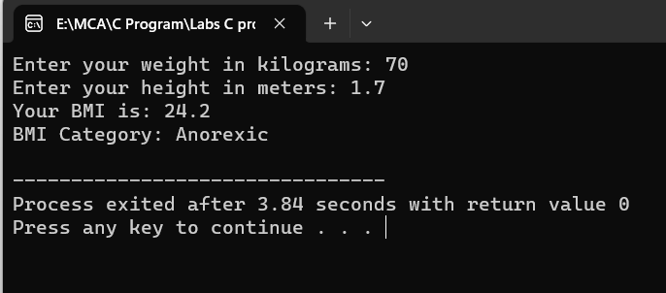}

**Output:-**

**Experiment no 3:** WAP to check if three points (x1,y1), (x2,y2) and (x3,y3) are collinear or not.

**Solution:-**

**Code:-**

#include<stdio.h>

int main()

{ /*collinear or not*/

int x1,y1,x2,y2,x3,y3,p;

printf("enter the value of x1 and y1");

scanf("%d%d",&x1,&y1);

printf("enter the value of x2 and y2\n");

scanf("%d%d",&x2,&y2);

printf("enter the value of x3 and y3\n");

scanf("%d%d",&x3,&y3);

p=x1*(y2-y3)+x2*(y3-y1)+x3*(y1-y2);

if(p==0)

{

printf("it is collinear");

}

else

{

printf("it is not collinear");

}

return 0;

}

**Output:-**

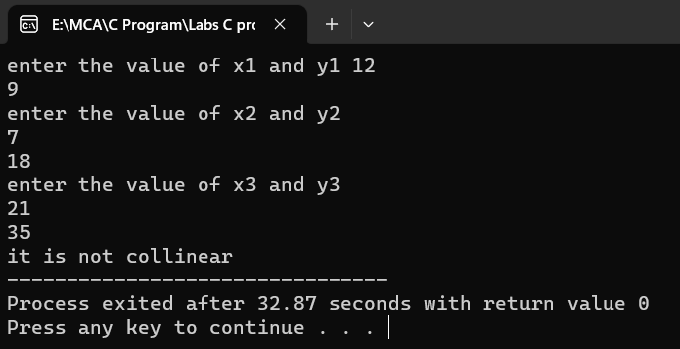

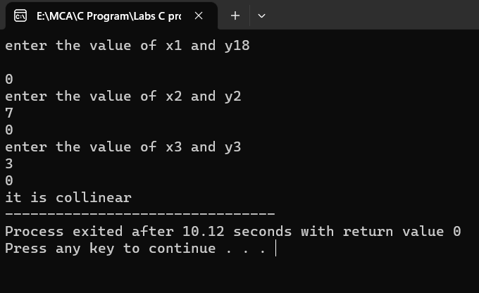

**Experiment No 4:** According to the gregorian calendar, it was Monday on the date 01/01/01. If Any year is input through the keyboard write a program to find out what is the day on 1st January of this year.

**Solution:-**

**Code:-**

#include<stdio.h>

#include<conio.h>

int main()

{

//basic year is chosen as the least year which user can enter through the keyboard where it should be Monday on 01th of January

int year, basic_year=1900, leap_year, remaining_year, total_days, day;

printf("Enter the year: ");

scanf("%d", &year);

year = (year-1)-basic_year; //we are calculating the total years between basic year and input year

//Now calculate the leap years

leap_year = year/4;

//calculate the year which are not leap years

remaining_year = year - leap_year;

//calculate total days present in all years

//remaining years are not leap year so total days in single year will be 365

//But in leap year we have 366 days in a single year

total_days = (remaining_year*365) + (leap_year*366) + 1;

//Find the actual day

day = total_days%7;

if(day==0)

printf("Monday");

else if(day==1)

printf("Tuesday");

else if(day==2)

printf("Wednesday");

else if(day==3)

printf("Thursday");

else if(day==4)

printf("Friday");

else if(day==5)

printf("Saturday");

else if(day==6)

printf("Sunday");

else

printf("Wrong Entry");

return 0;

}

**Output:-**

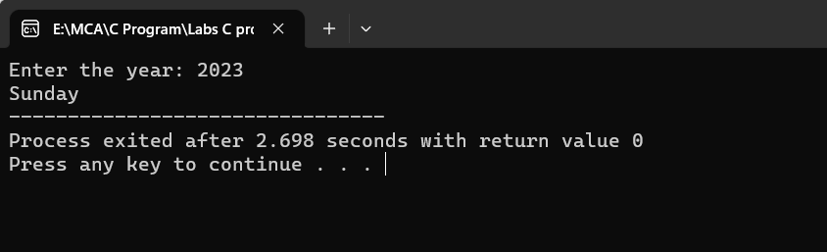

**Experiment 5:** WAP using ternary operator, the user should input the length and breadth of a rectangle, one has to find out which rectangle has the highest perimeter. The minimum number of rectangles should be three.

**Solution:-**

**Code:-**

**#include <stdio.h>**

**int main() {**

**int length1, breadth1, length2, breadth2, length3, breadth3;**

**// Input for Rectangle 1**

**printf("Enter the length and breadth of Rectangle 1: ");**

**scanf("%d %d", &length1, &breadth1);**

**// Input for Rectangle 2**

**printf("Enter the length and breadth of Rectangle 2: ");**

**scanf("%d %d", &length2, &breadth2);**

**// Input for Rectangle 3**

**printf("Enter the length and breadth of Rectangle 3: ");**

**scanf("%d %d", &length3, &breadth3);**

**// Calculate perimeters**

**int perimeter1 = 2 * (length1 + breadth1);**

**int perimeter2 = 2 * (length2 + breadth2);**

**int perimeter3 = 2 * (length3 + breadth3);**

**// Find the rectangle with the highest perimeter using ternary operator**

**int maxPerimeter = (perimeter1 > perimeter2) ? ((perimeter1 > perimeter3) ?**

**perimeter1 : perimeter3) : ((perimeter2 > perimeter3) ? perimeter2 :**

**perimeter3);**

**// Determine which rectangle has the highest perimeter and print the result**

**if (maxPerimeter == perimeter1) {**

**printf("Rectangle 1 has the highest perimeter.\n");**

**} else if (maxPerimeter == perimeter2) {**

**printf("Rectangle 2 has the highest perimeter.\n");**

**} else {**

**printf("Rectangle 3 has the highest perimeter.\n");**

**}**

**return 0;**

**}**

**Output:-**

